Table of Contents

Easy
2020 — Q.13 — Database / SQL 2020 — Q.28 — Digital Logic
2021 — Q.29 — Computer Networks / Error Detection 2022 — Q.22 — Computer Networks
2023 — Q.30 — Graph Theory / Linear Algebra 2024 — Q.20 — ER Modeling / DBMS
2025 — Q.31 — Digital Logic
2026 — Q.37 — Digital Logic / Sequential Circuits
Basic-Medium
2020 — Q.4 — Computer Organization / Datapath 2020 — Q.30 — Computer Architecture / Cache 2021 — Q.28 — Digital Logic / Counters
2021 — Q.38 — Theory of Computation / DFA
2022 — Q.12 — Theory of Computation / Regular Expressions 2022 — Q.40 — Digital Logic / Memory Organization
2023 — Q.37 — Compiler / Data-Flow Analysis
2023 — Q.42 — Computer Organization / Memory Decoding 2024 — Q.28 — Digital Logic / Hazards
2024 — Q.64 — Digital Logic / Multiplexers 2025 — Q.43 — Digital Logic / Karnaugh Map 2026 — Q.42 — Compiler / Data-Flow Analysis
2026 — Q.60 — Computer Architecture / Pipeline
Medium
2021 — Q.47 — Data Structures / Dynamic Hashing 2021 — Q.54 — Probability / Communication Channel 2022 — Q.50 — Graph Theory / Peterson Graph
2023 — Q.14 — Theory of Computation / DFA 2023 — Q.40 — Theory of Computation / PDA 2023 — Q.44 — Digital Logic / Multiplexers 2023 — Q.47 — Data Structures / Binary Tree
2024 — Q.37 — Compiler / Syntax-Directed Definition 2025 — Q.59 — Data Structures / BFS and Trees 2026 — Q.50 — Algorithms / DFS

Q.13 | 2020 | Session 6
Difficulty: Easy | Topic: Database / SQL

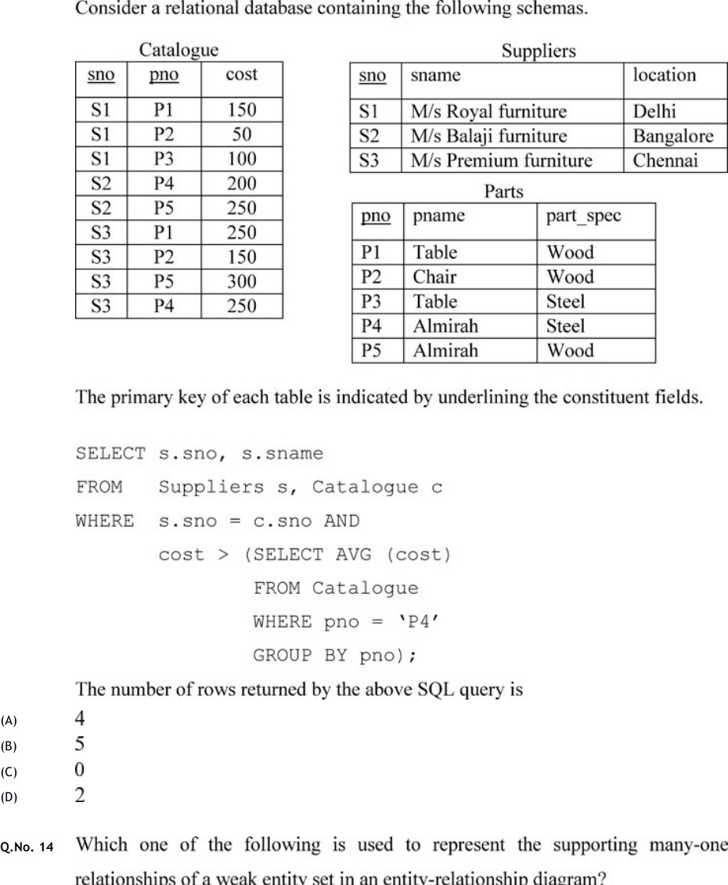

  - | 2020 | Session 6
Difficulty: Easy | Topic: Digital Logic

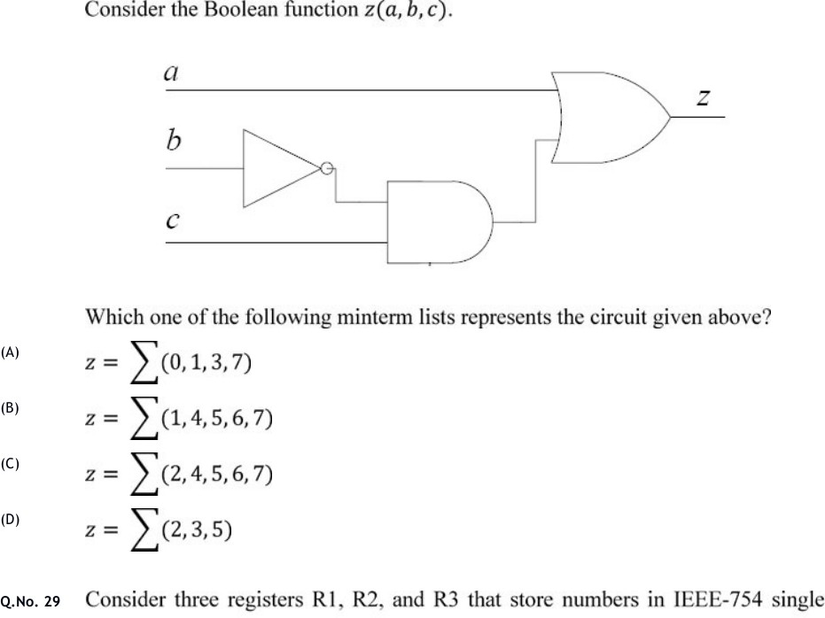

  - | 2021 | CS Set-1
Difficulty: Easy | Topic: Computer Networks / Error Detection

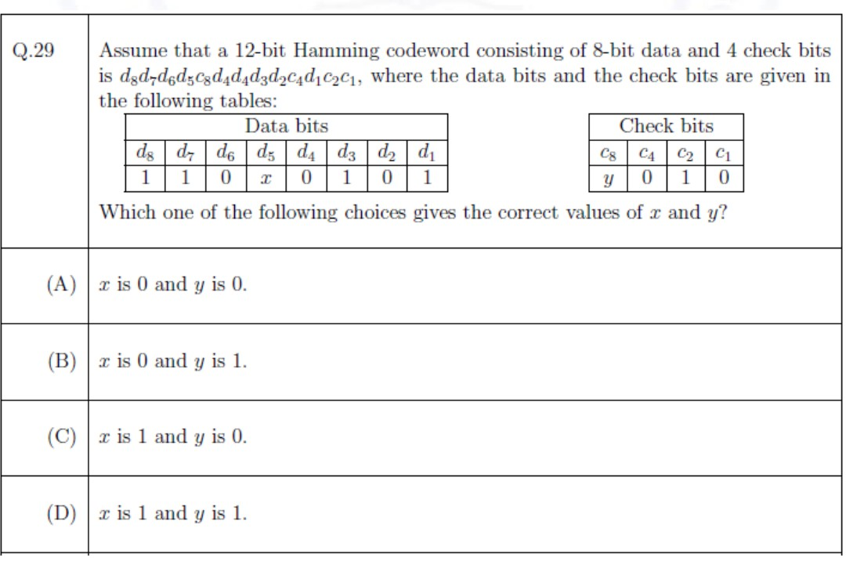

Q.22 | 2022 | CS
Difficulty: Easy | Topic: Computer Networks

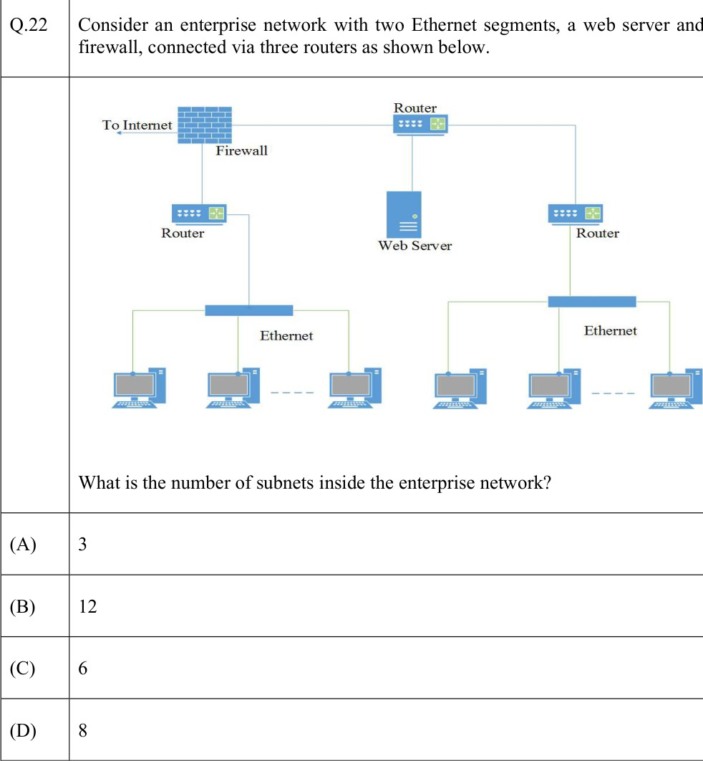

  - | 2023 | CS
Difficulty: Easy | Topic: Graph Theory / Linear Algebra

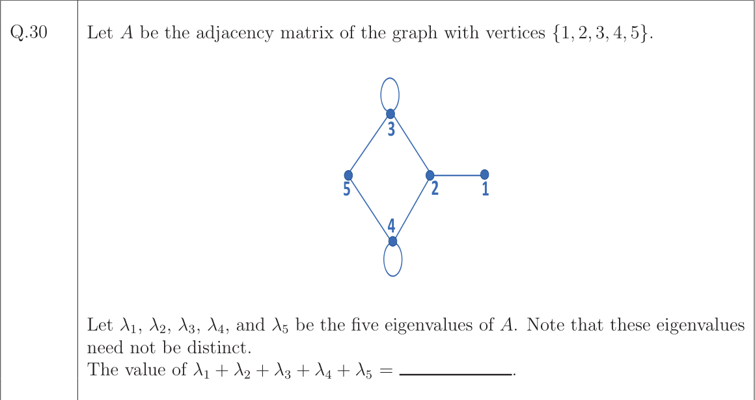

Q.20 | 2024 | Set 1 (CS1)
Difficulty: Easy | Topic: ER Modeling / DBMS

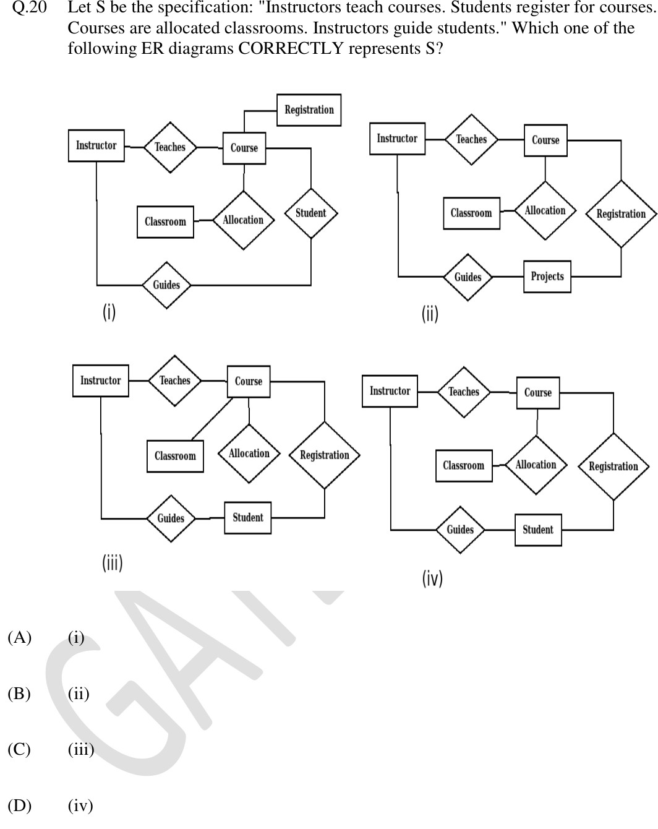

  - | 2025 | CS2
Difficulty: Easy | Topic: Digital Logic

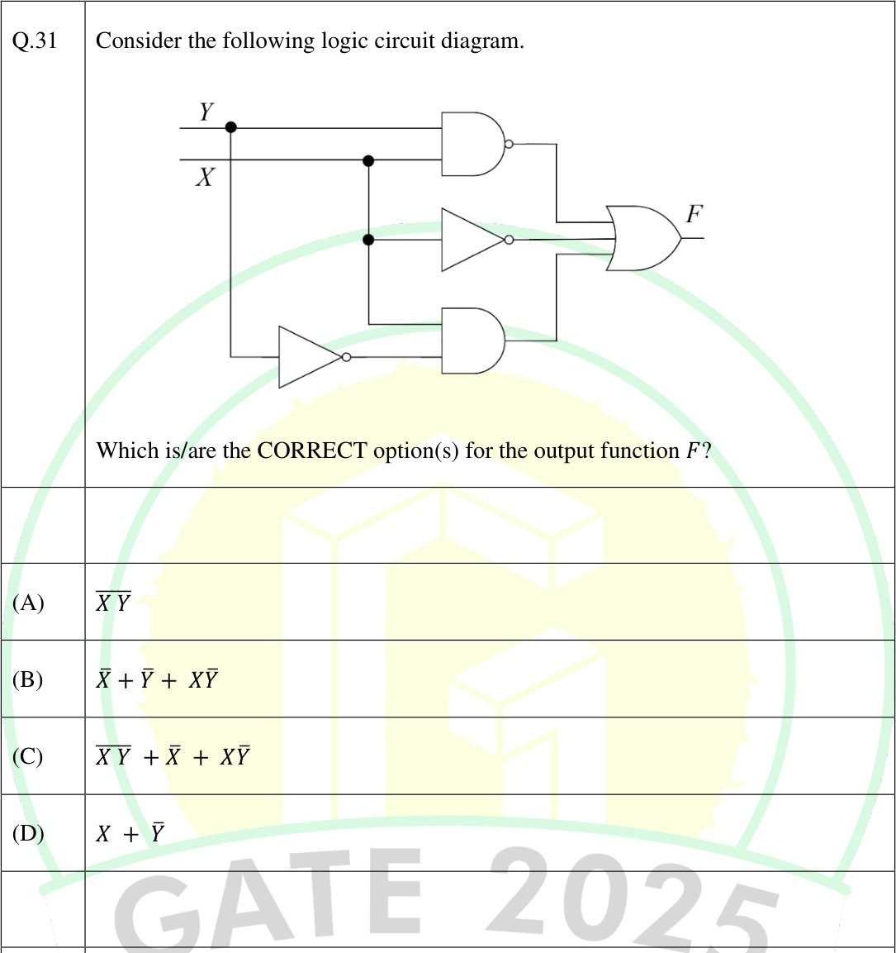

Q.4 | 2020 | Session 6
Difficulty: Basic-Medium | Topic: Computer Organization / Datapath

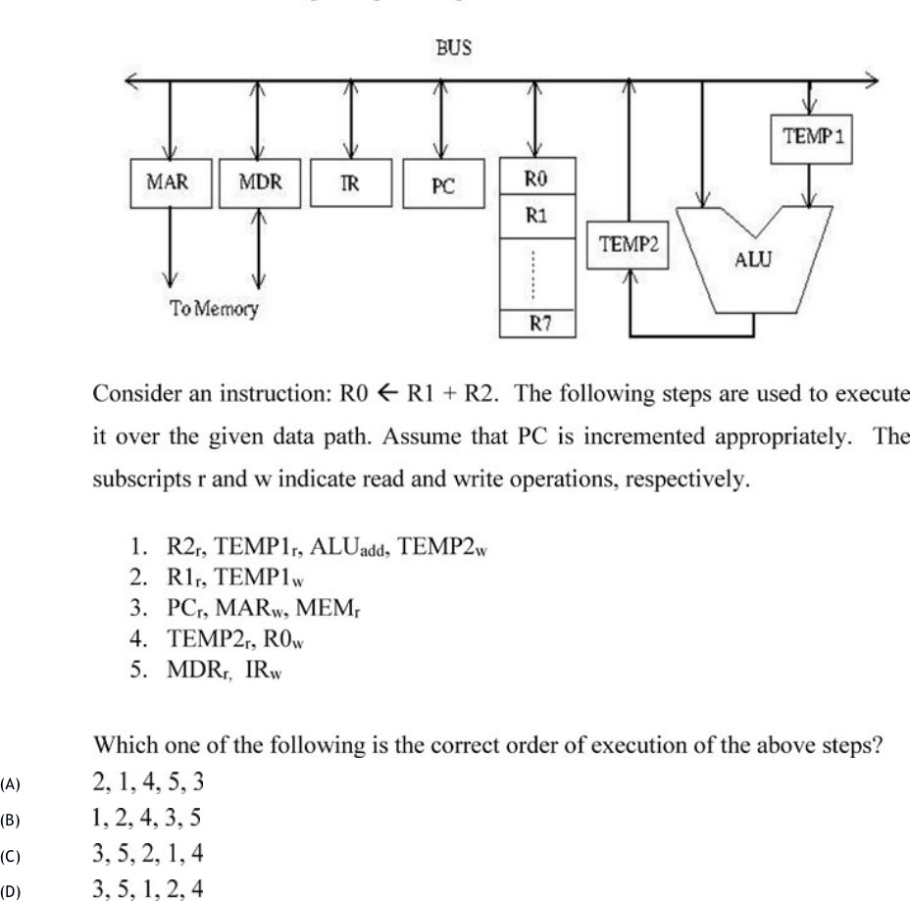

Q.30 | 2020 | Session 6
Difficulty: Basic-Medium | Topic: Computer Architecture / Cache

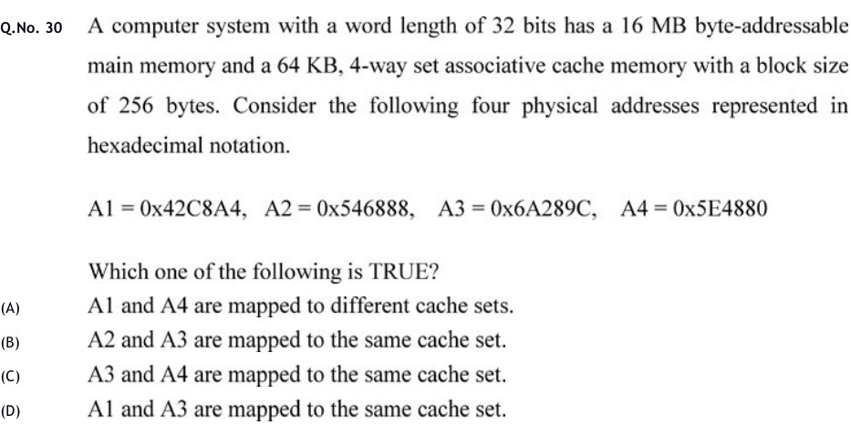

Q.28 | 2021 | CS Set-1
Difficulty: Basic-Medium | Topic: Digital Logic / Counters

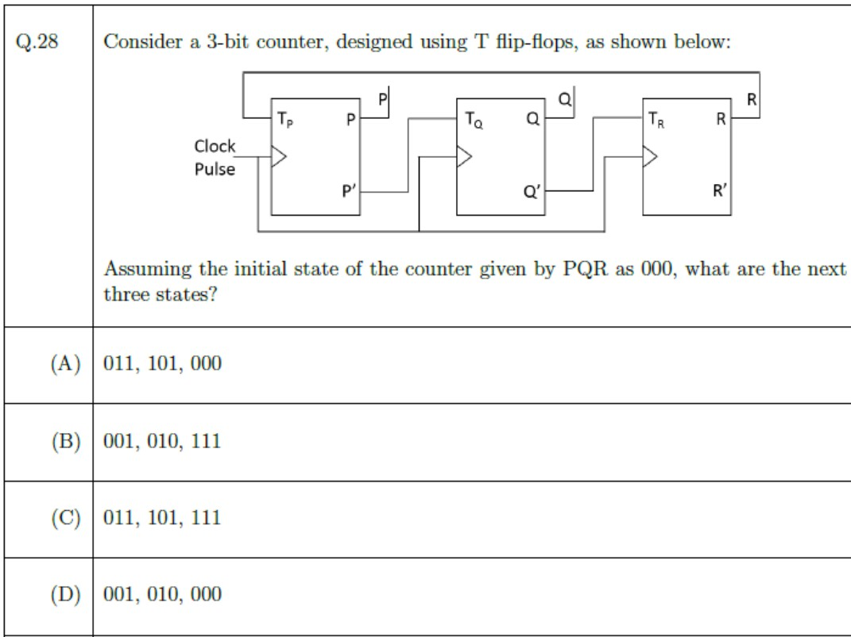

Q.38 | 2021 | CS Set-1
Difficulty: Basic-Medium | Topic: Theory of Computation / DFA

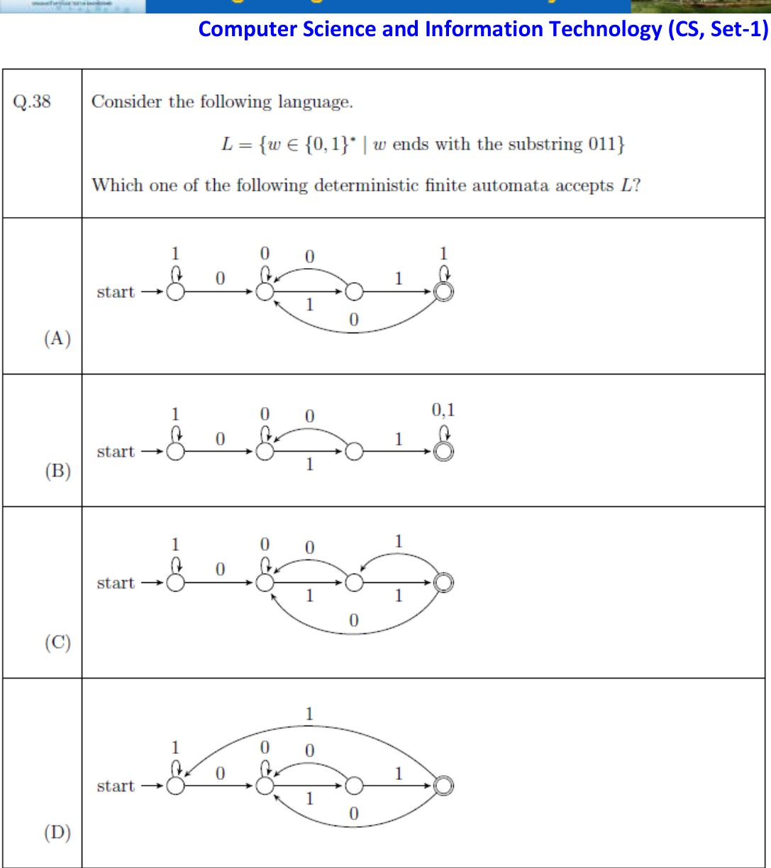

Q.12 | 2022 | CS
Difficulty: Basic-Medium | Topic: Theory of Computation / Regular Expression

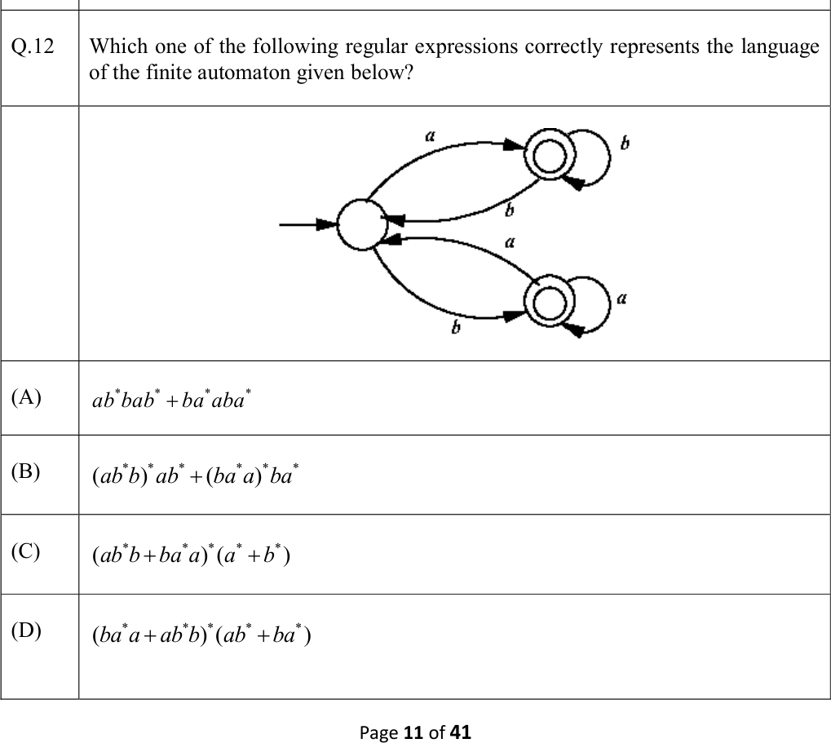

Q.40 | 2022 | CS
Difficulty: Basic-Medium | Topic: Digital Logic / Memory Organization

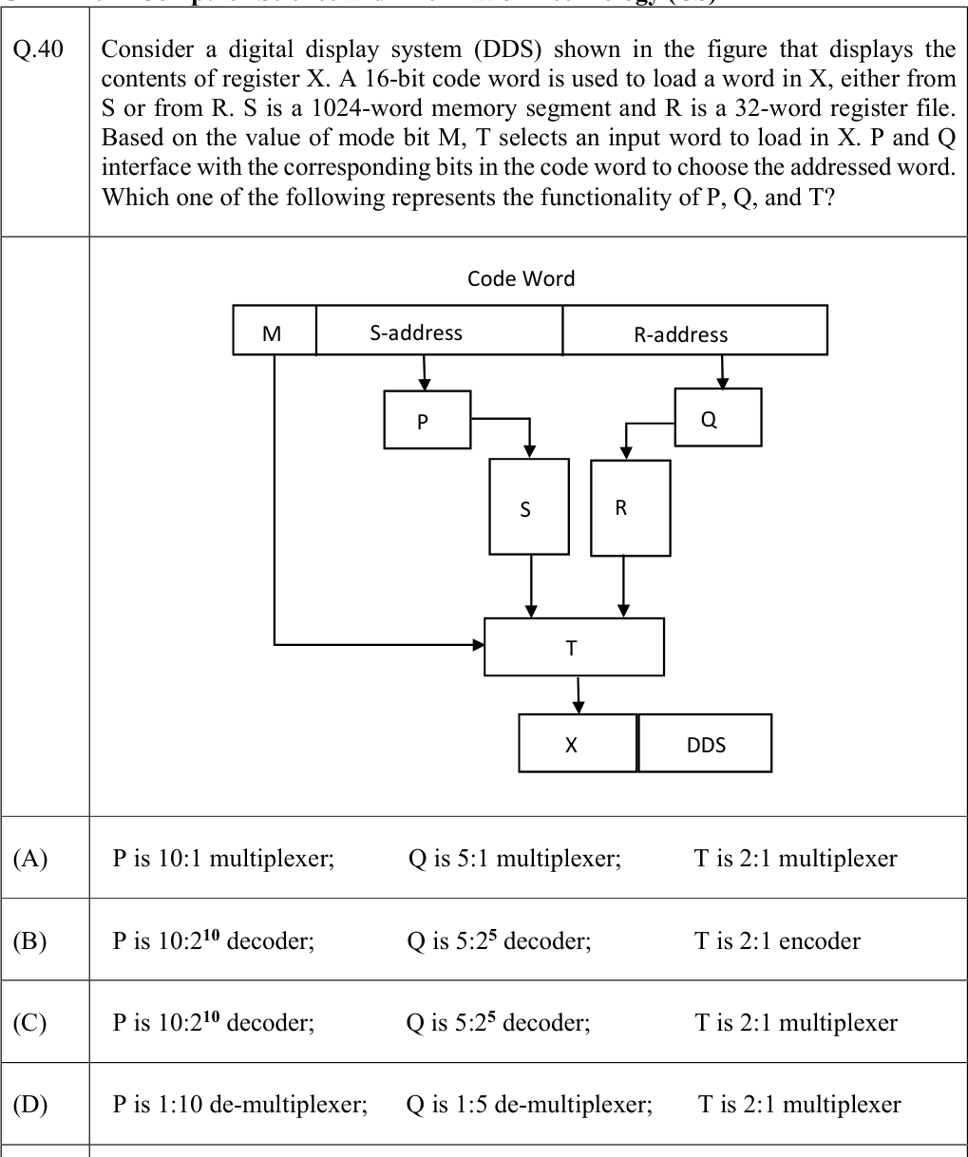

Q.37 | 2023 | CS
Difficulty: Basic-Medium | Topic: Compiler / Data-Flow Analysis

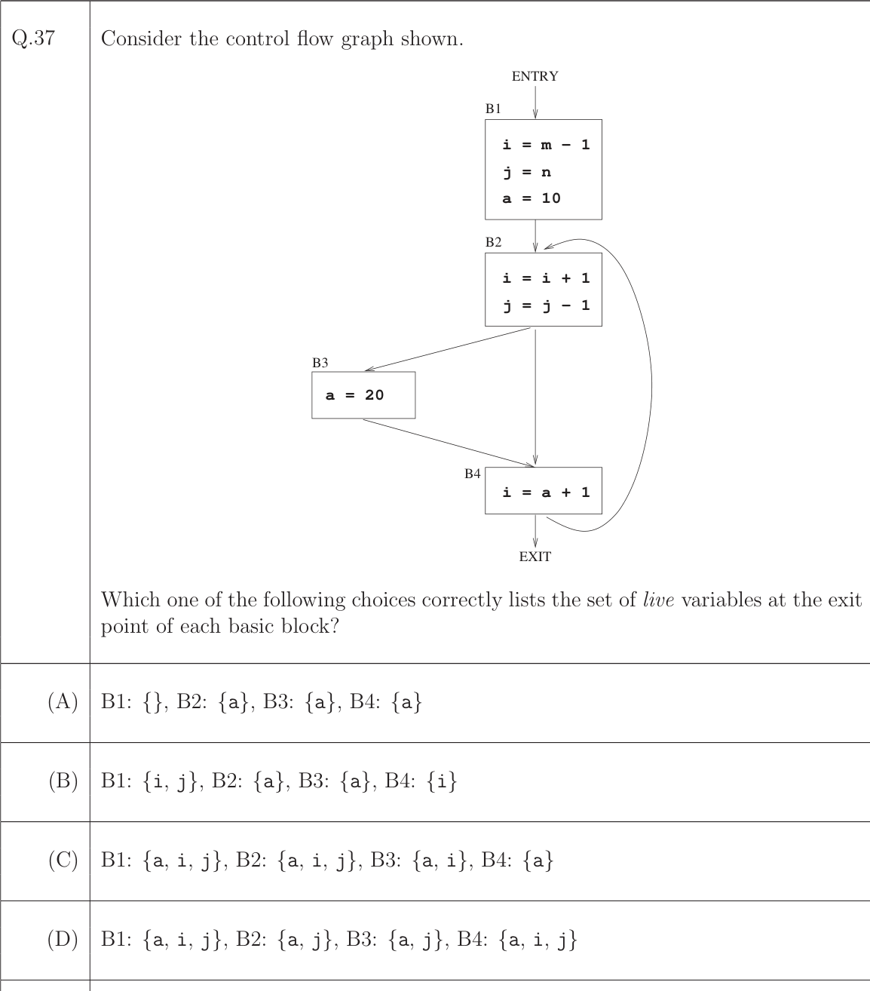

  - | 2023 | CS
Difficulty: Basic-Medium | Topic: Computer Organization / Memory Decoding

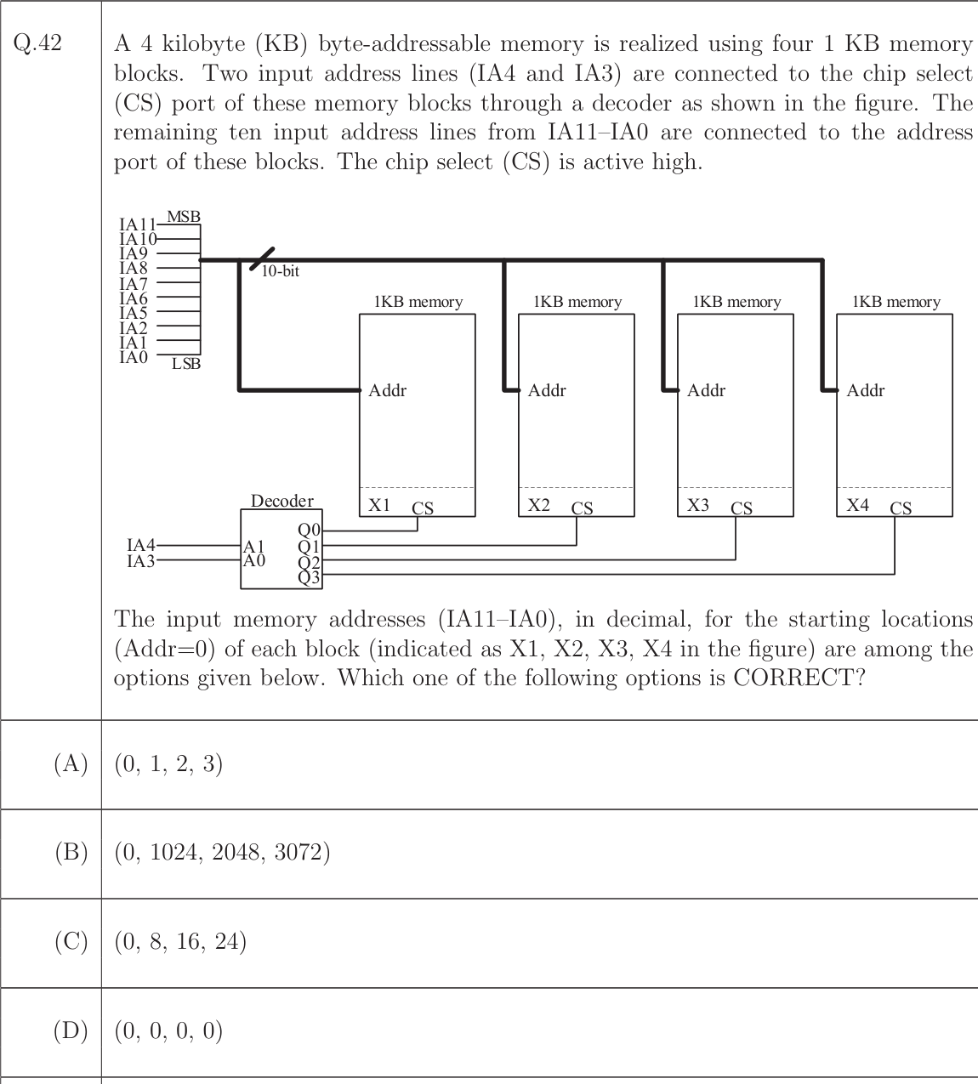

Q.28 | 2024 | Set 1 (CS1)
Difficulty: Basic-Medium | Topic: Digital Logic / Hazards

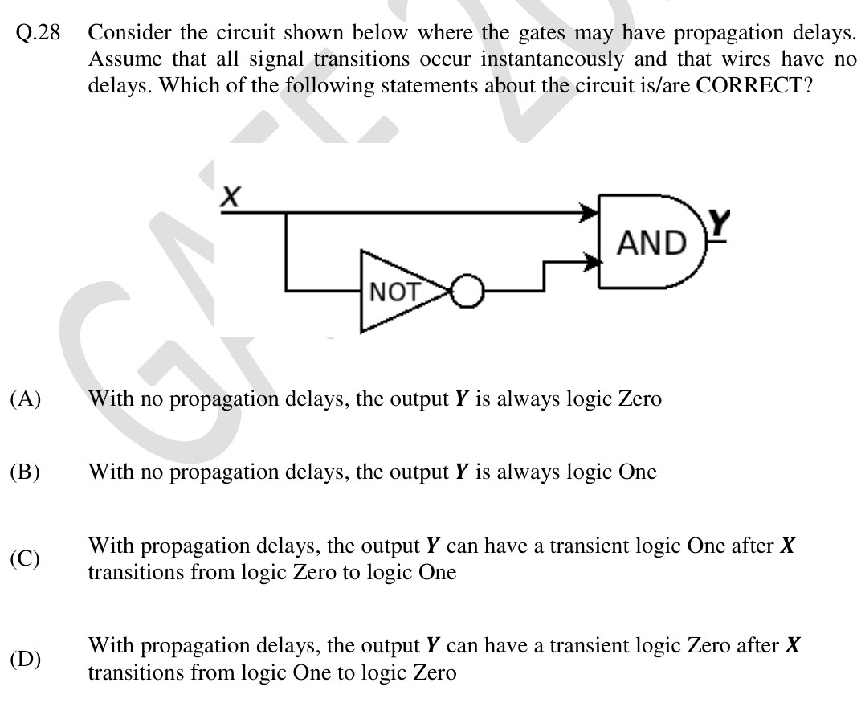

Q.64 | 2024 | Set 1 (CS1)
Difficulty: Basic-Medium | Topic: Digital Logic / Multiplexers

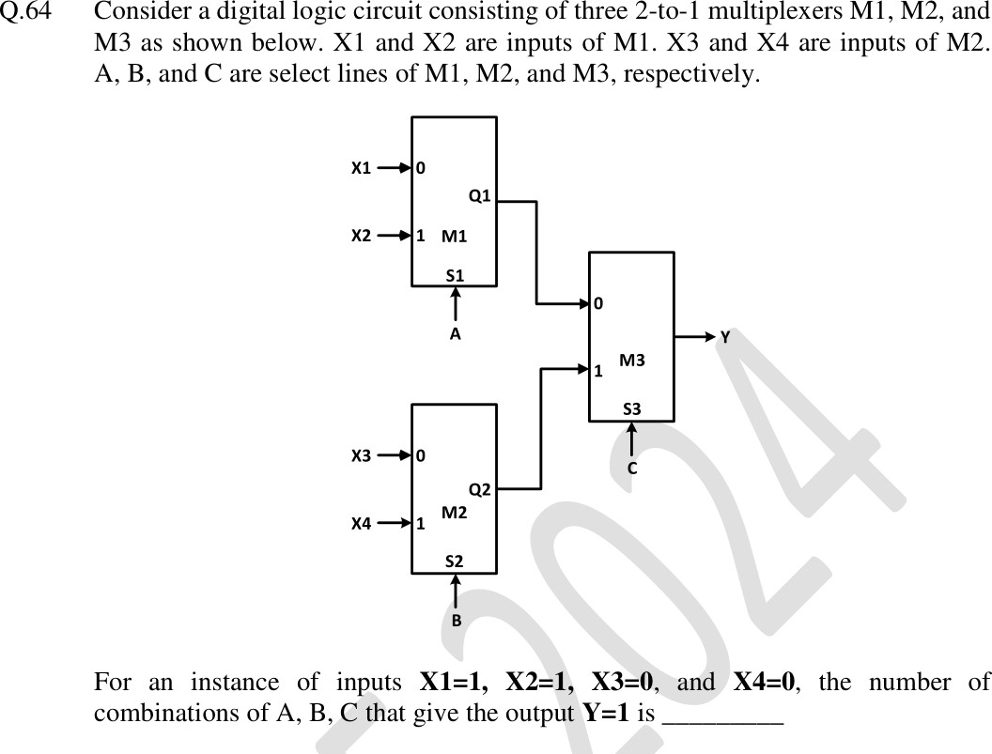

  - | 2025 | CS2
Difficulty: Basic-Medium | Topic: Digital Logic / Karnaugh Map

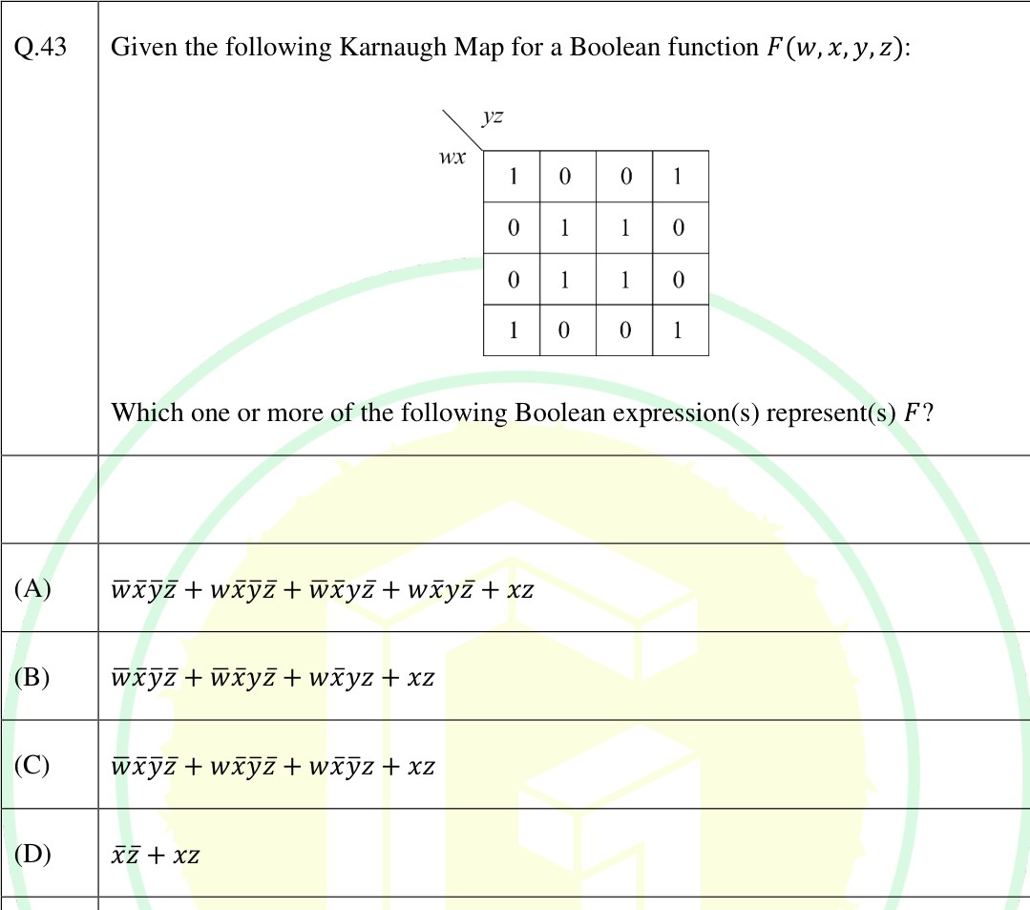

Q.42 | 2026 | CS1
Difficulty: Basic-Medium | Topic: Compiler / Data-Flow Analysis

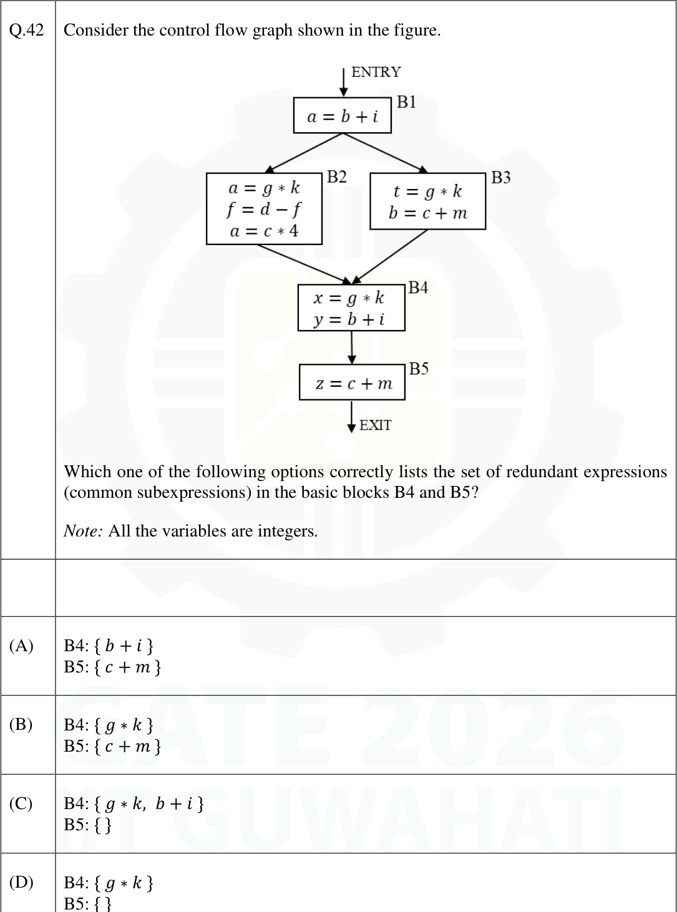
Q.47 | 2021 | CS Set-1
Difficulty: Medium | Topic: Data Structures / Dynamic Hashing

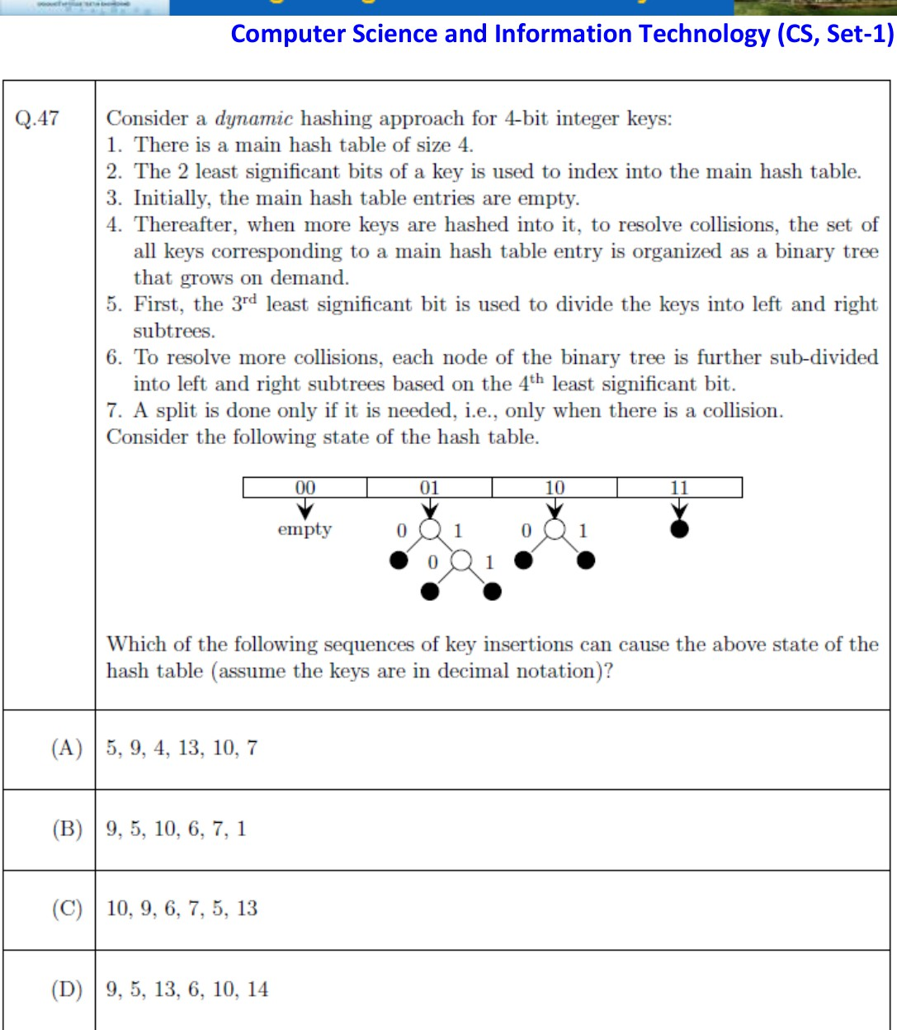

Q.54 | 2021 | CS Set-1
Difficulty: Medium | Topic: Probability / Communication Channel

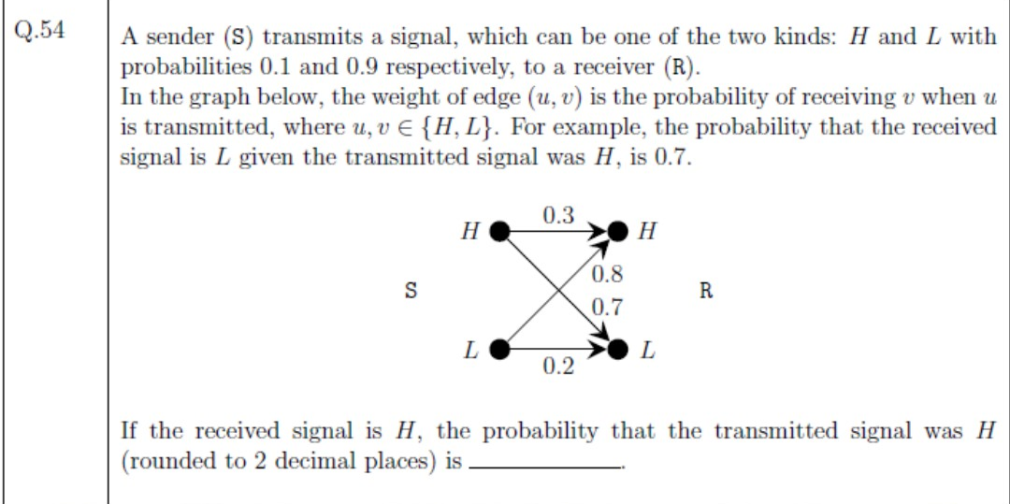

Q.50 | 2022 | CS
Difficulty: Medium | Topic: Graph Theory / Peterson Graph

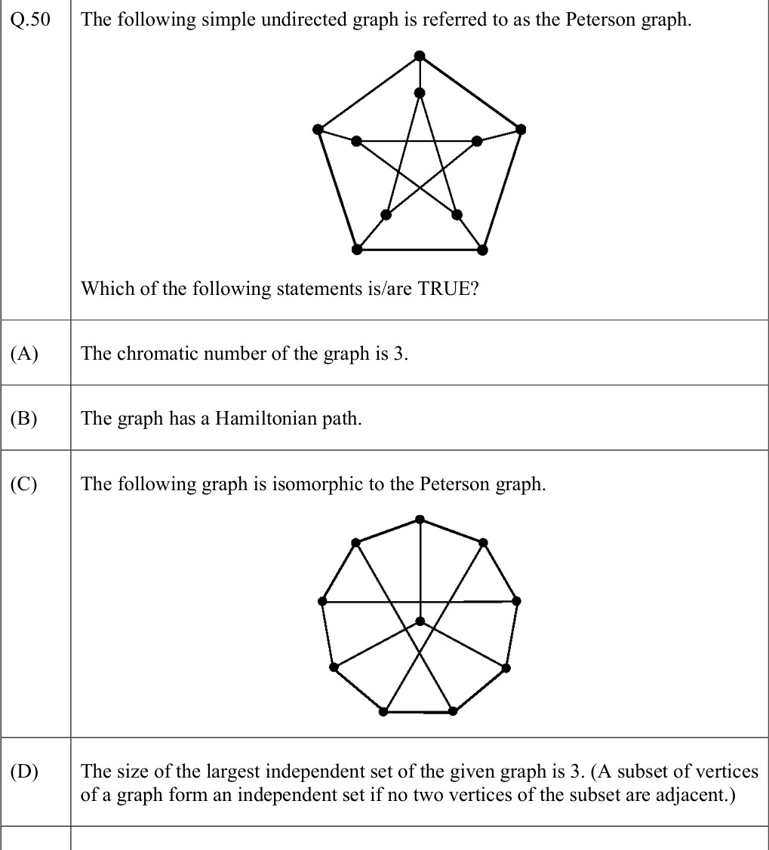

Q.14 | 2023 | CS
Difficulty: Medium | Topic: Theory of Computation / DFA

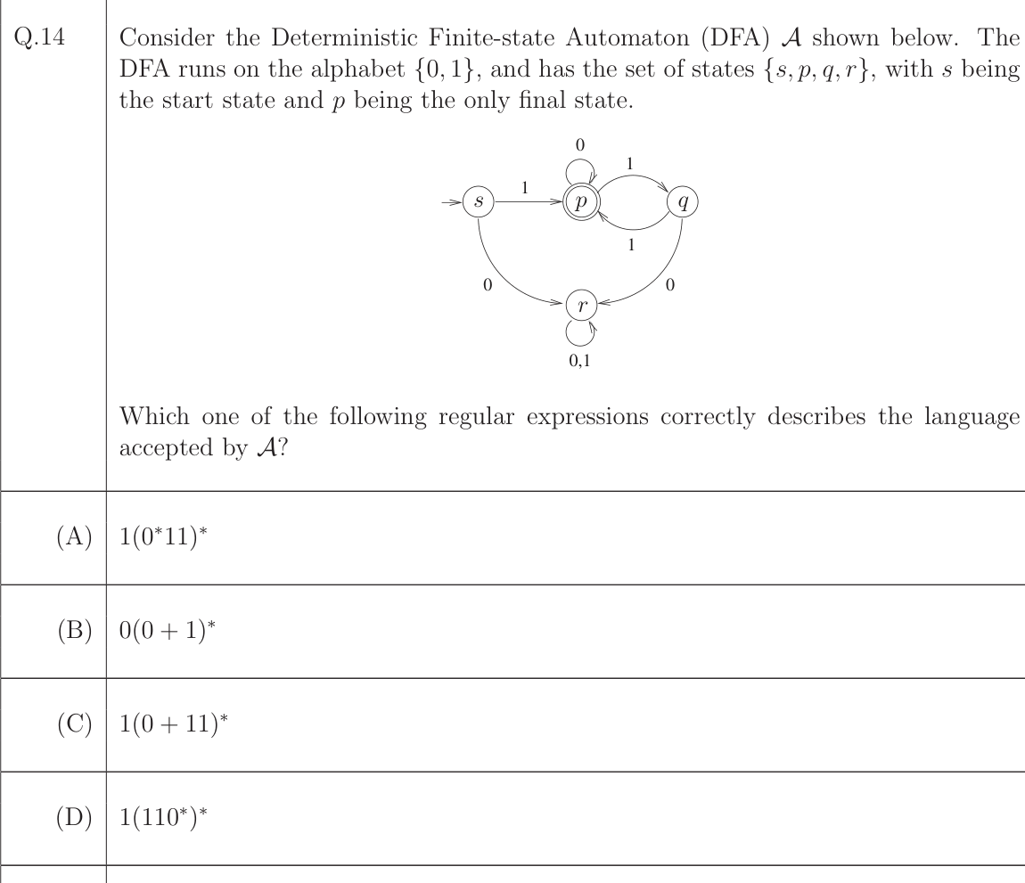

Q.40 | 2023 | CS
Difficulty: Medium | Topic: Theory of Computation / PDA

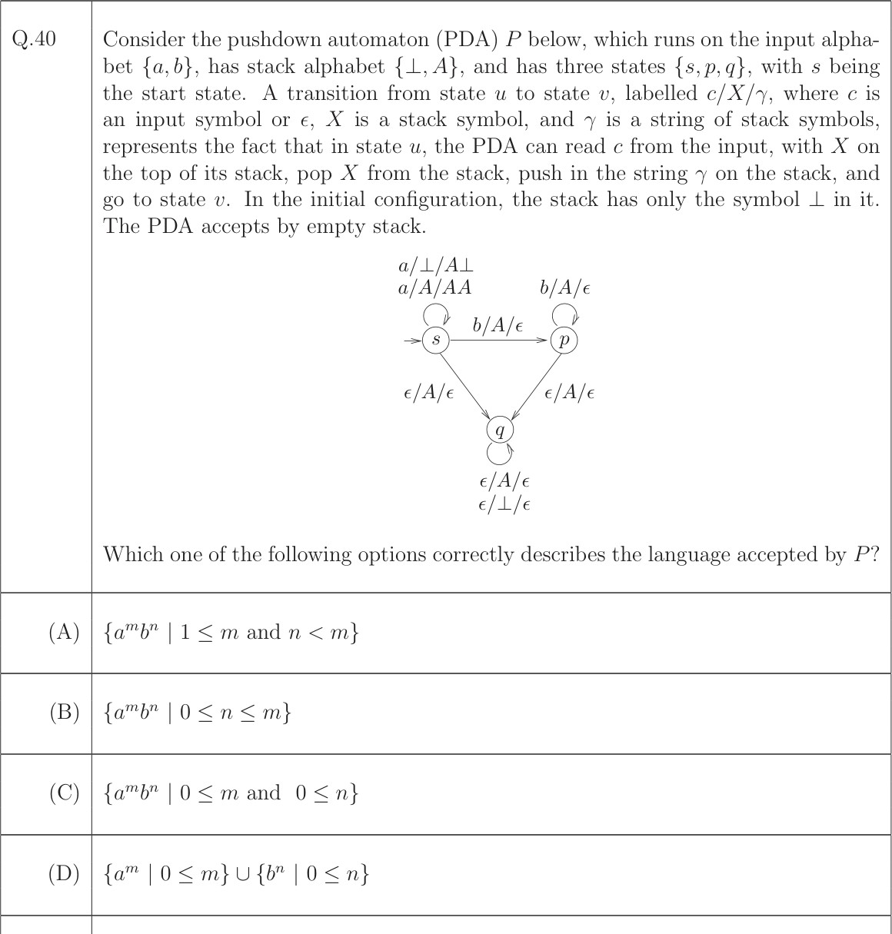

  - | 2023 | CS
Difficulty: Medium | Topic: Digital Logic / Multiplexers

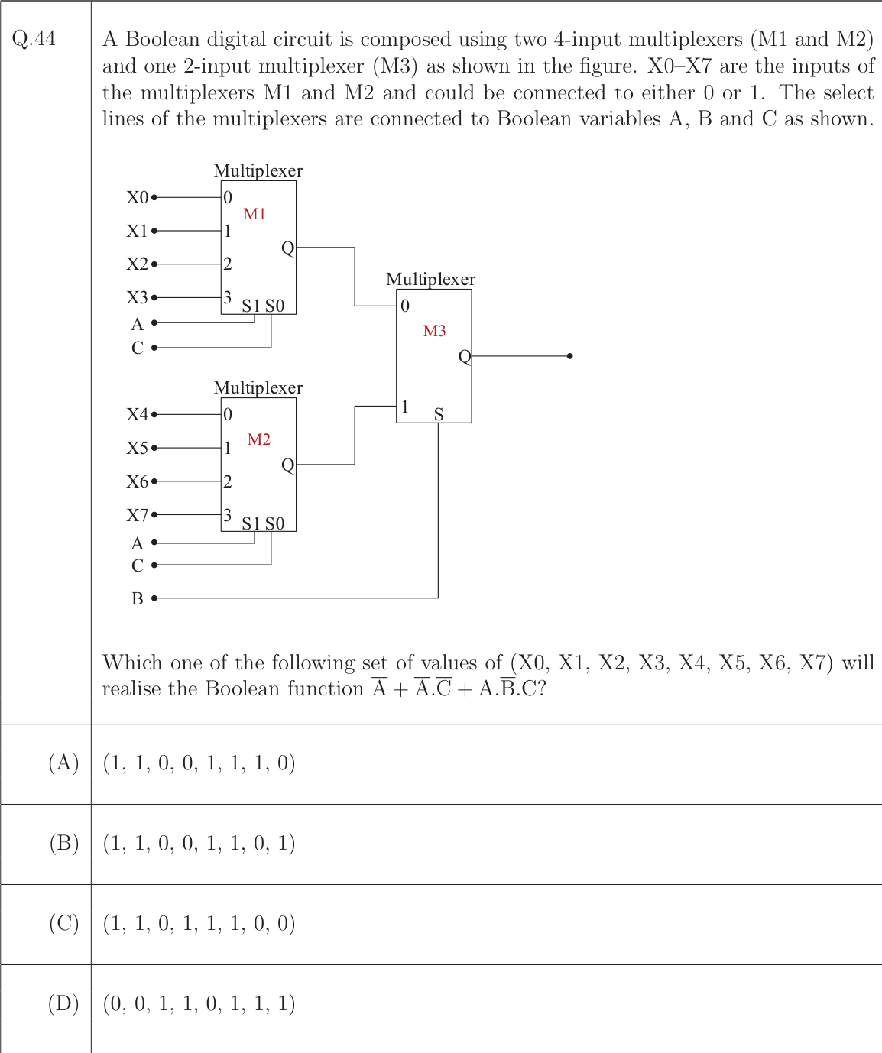

Q.47 | 2023 | CS
Difficulty: Medium | Topic: Data Structures / Binary Tree

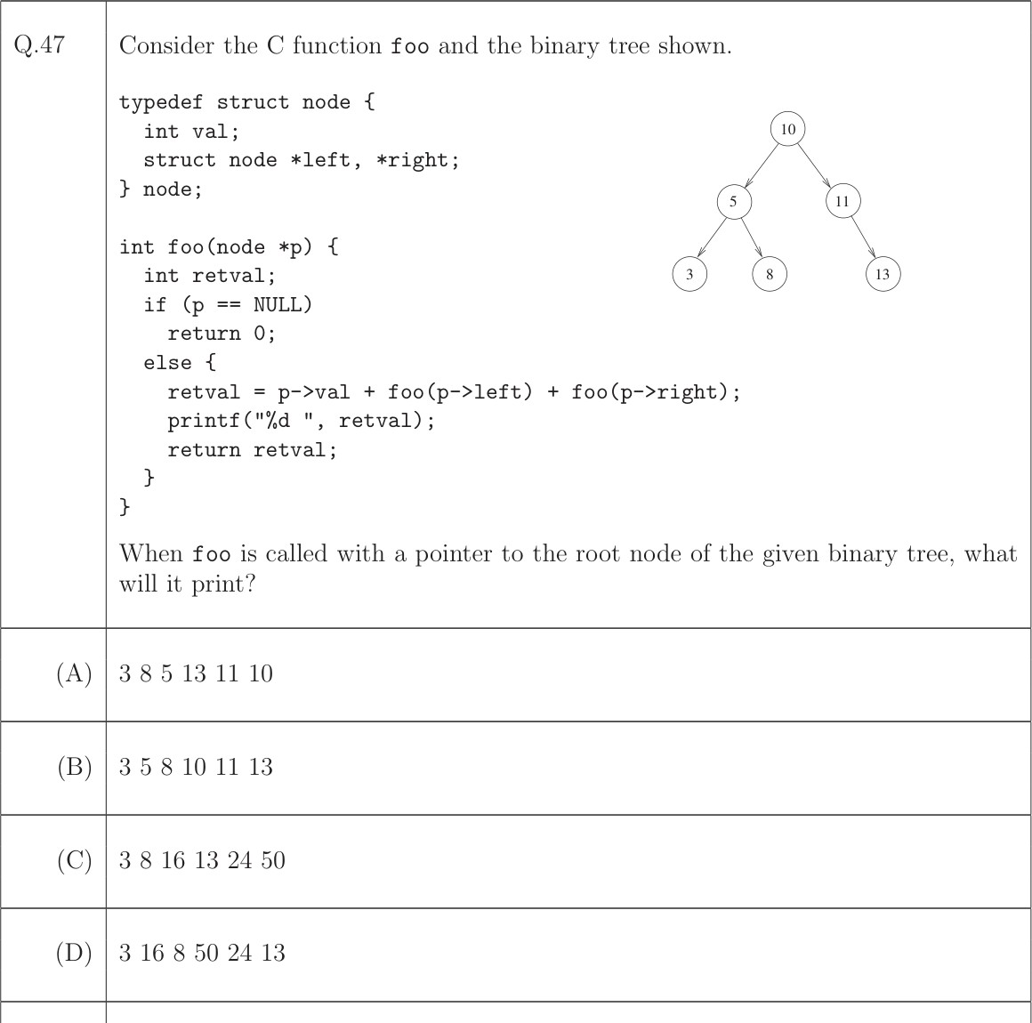

Q.37 | 2024 | Set 1 (CS1)
Difficulty: Medium | Topic: Compiler / Syntax-Directed Definition

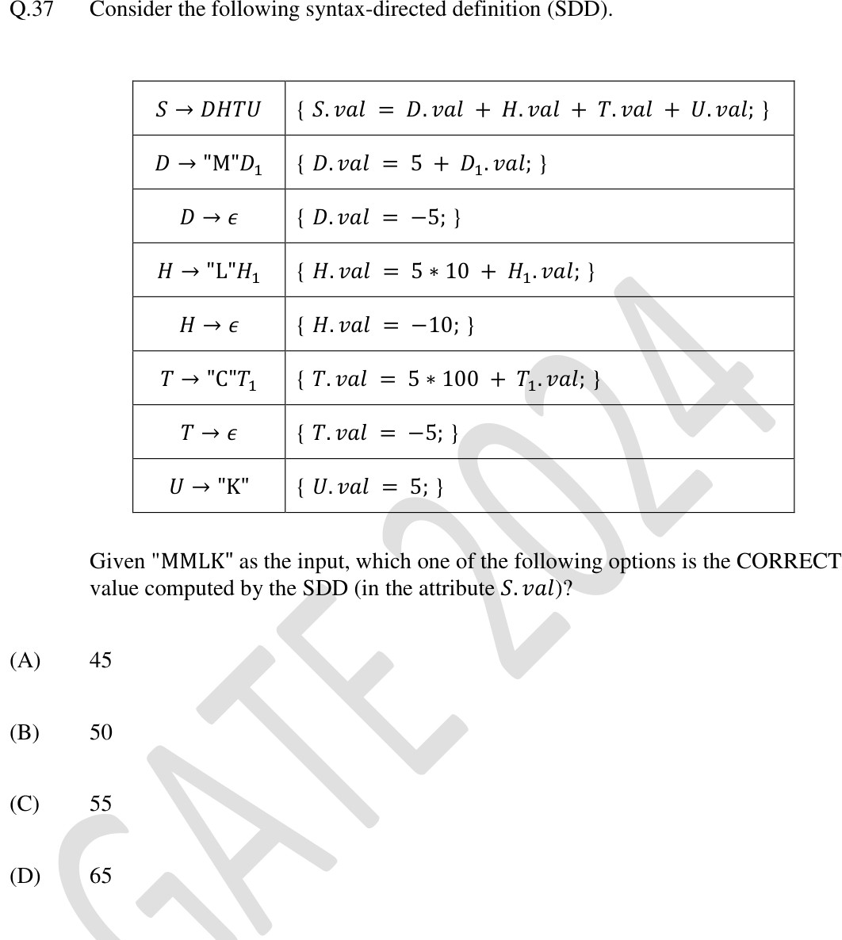

Q.59 | 2025 | CS2
Difficulty: Medium | Topic: Data Structures / BFS and Trees

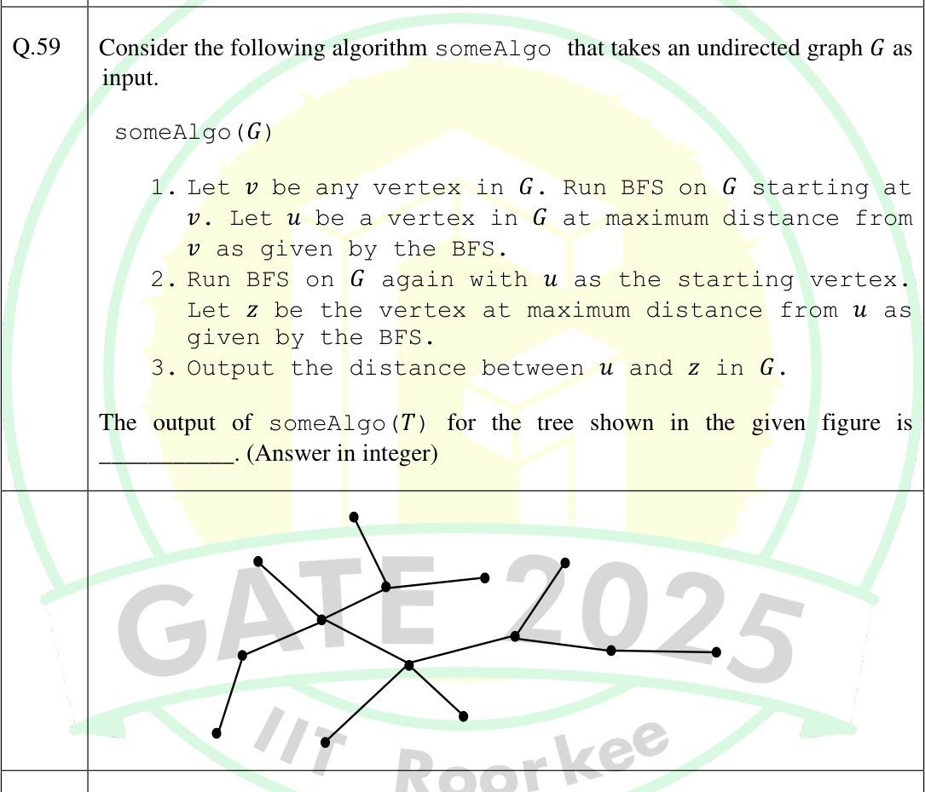

Q.50 | 2026 | CS1
Difficulty: Medium | Topic: Algorithms / DFS

